Chapter 16, Solution 17.

If i_{s}(t) = e^{-2t}u(t) A in the circuit shown in Fig. 16.40, find the value of i_{o}(t).

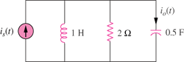

Figure 16.40
For Prob. 16.17.

Solution

s

I_{o}

2

(-1+-sqrt(1-8))/2 = (-1+-(j2.646))/2 = -0.5+-j(1.3229)

= [e^{–2t} – 0.7559e^{–0.5t} sin(1.3229t)]u(t) A or i_{o}(t) =

